NAAN MUDHALVAN ARTS INTERNSHIP PROGRAM 2026

PYTHON FOR DATA ANALYTICS PROJEC

STUDENT NAME: G. Mareeswari
YEAR: 2026
COLLEGE CODE: 137
COLLEGE NAME: Government Arts and Science College for Women, Alangulam
DEPARTMENT: Computer Science
SEMESTER: V
ROLL NO: 24081371802112128
NMID: 41e0bff7aec2ffb8a4a4dee785522627@nm2026.in
TITLE: HR Employee Attrition Analysis Using Python
GITHUB LINK:
DATE: 22-06-2026

ABSTRACT
This project analyzes employee attrition data to understand the factors that influence employees to leave an organization. The IBM HR Employee Attrition dataset was used for analysis. Python libraries such as Pandas, NumPy, Matplotlib, and Seaborn were used in Google Colab. Data preprocessing, exploratory data analysis (EDA), and visualization techniques were applied to identify patterns related to employee attrition. The analysis focused on factors such as age, monthly income, overtime, and job satisfaction. The visualizations helped identify key trends affecting employee turnover. The project provides useful insights that can help organizations improve employee retention and reduce attrition rates.

PROBLEM STATEMENT
Employee attrition is a major challenge for many organizations. When employees leave frequently, companies face increased recruitment costs, productivity loss, and training expenses. Understanding the reasons behind employee attrition is important for improving employee satisfaction and retention. Data analysis helps identify patterns and factors influencing employee turnover, enabling organizations to take preventive actions.

OBJECTIVES
  - Analyze employee attrition data.
  - Identify factors affecting employee turnover.
  - Visualize attrition trends using charts.
  - Generate meaningful insights into decision-making.
  - Improve understanding of employee retention strategies.

PROJECT SCOPE
This project focuses on analyzing HR employee attrition data using Python in Google Colab. The project includes data loading, preprocessing, exploratory data analysis, visualization, and interpretation of results.

TECHNOLOGIES USED

Development Environment

Google Colab

Programming Language

Python

Libraries Used

Pandas – Data manipulation

NumPy – Numerical operations

Matplotlib – Data visualization

Seaborn – Statistical visualization

Dataset Source

IBM HR Employee Attrition Dataset (CSV File)

APPLICATION FLOW

Load dataset into Google Colab.

Import required libraries.

Explore dataset structure.

Perform data cleaning and preprocessing.

Analyze employee attrition patterns.

Create visualizations.

Generate insights and conclusions.

KEY PYTHON DATA ANALYTICS CONCEPTS USED
- Data Handling
- Dataset loading using Pandas.
- Data Cleaning
- Checking missing values and data consistency.
- Exploratory Data Analysis (EDA)
- Understanding employee demographics and attrition patterns.
- Visualization
- Using count plots and box plots to visualize relationships.

EXPECTED OUTPUT

Dataset Preview
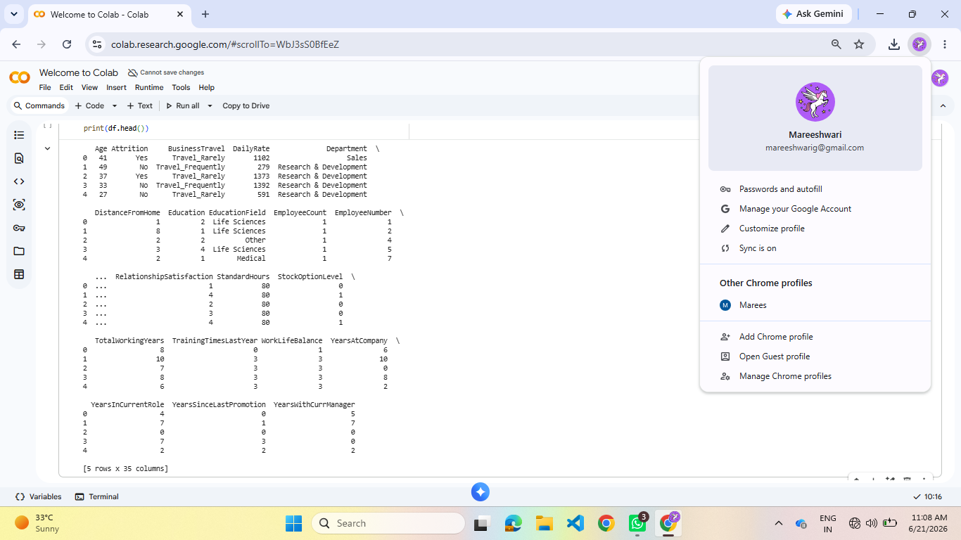

Dataset Information
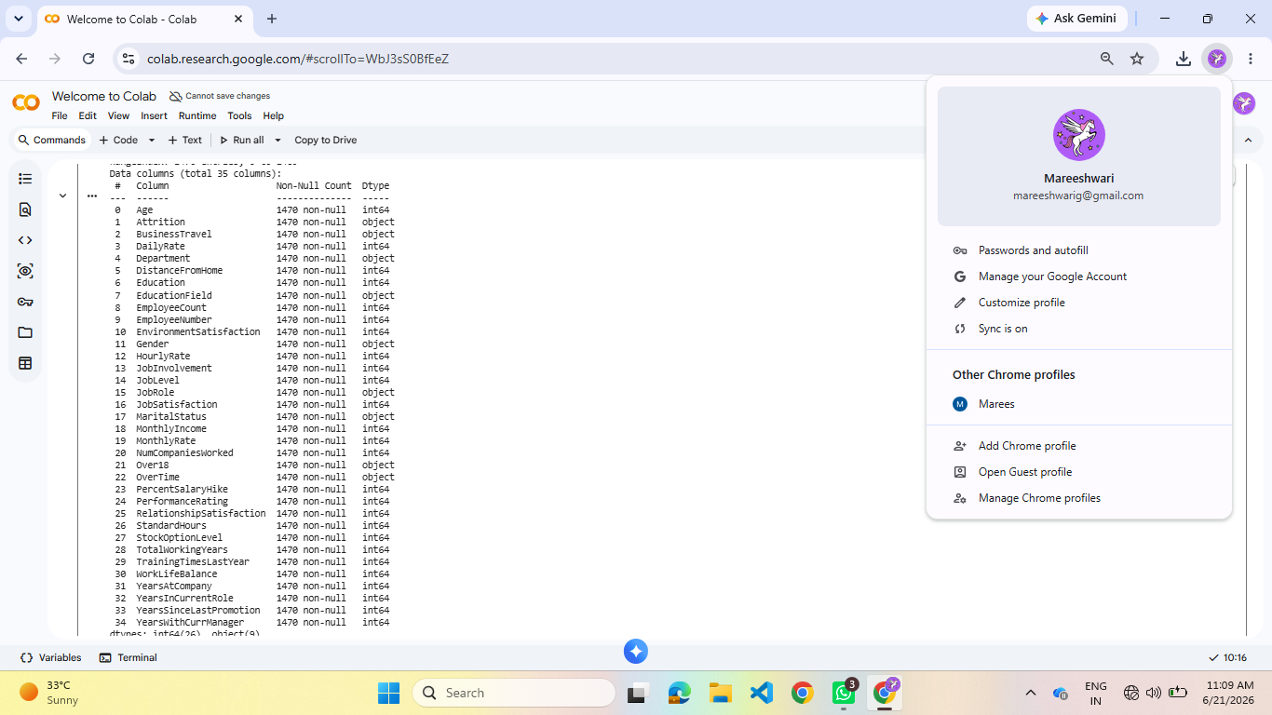

Attrition Count
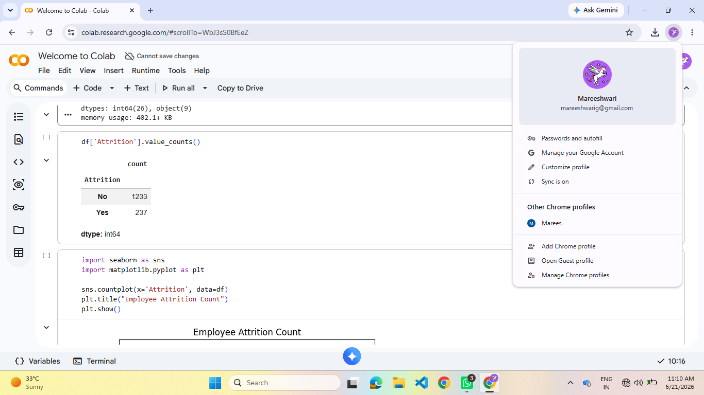

- Employee Attrition Count Graph
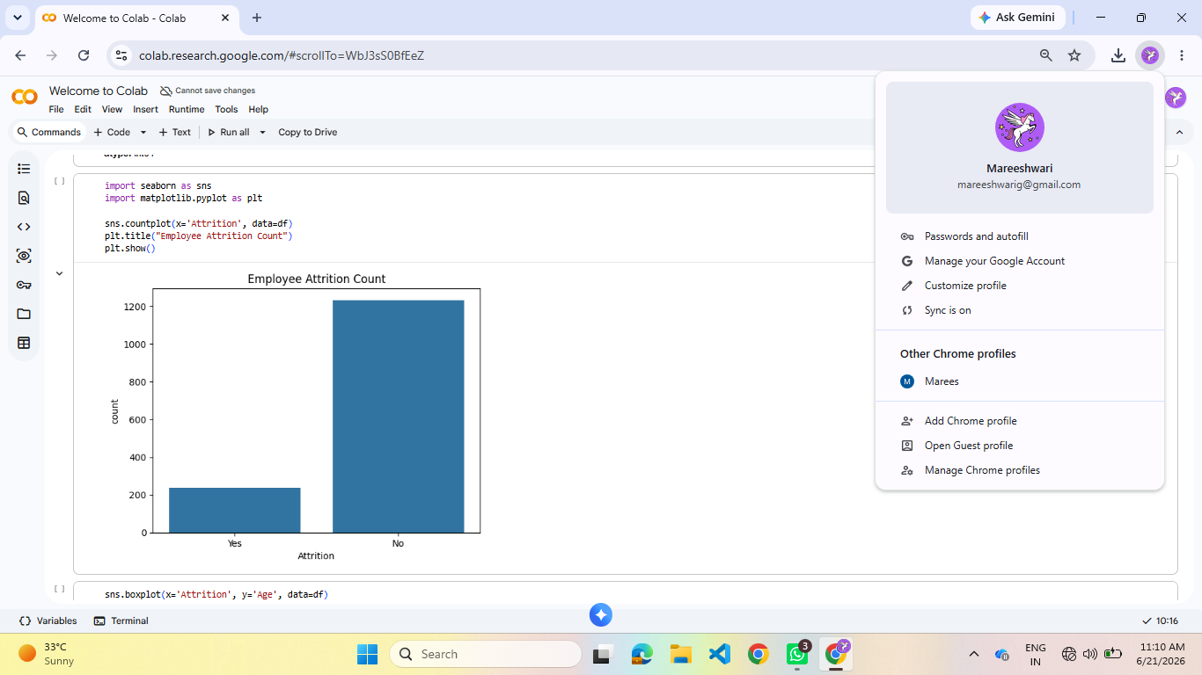

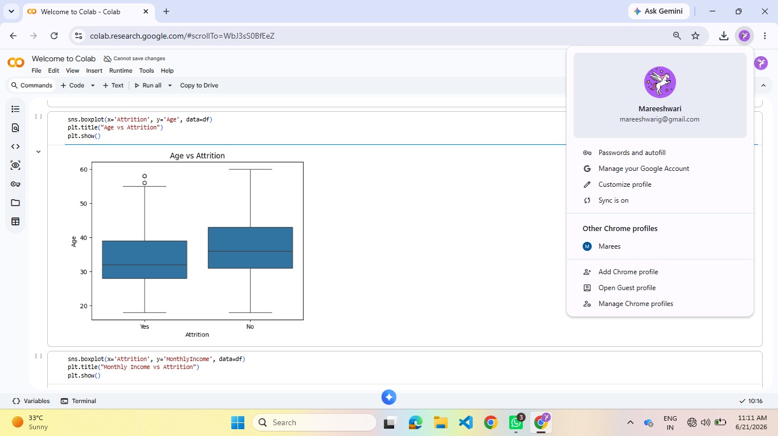
- Age vs Attrition Graph

- Monthly Income vs Attrition Graph
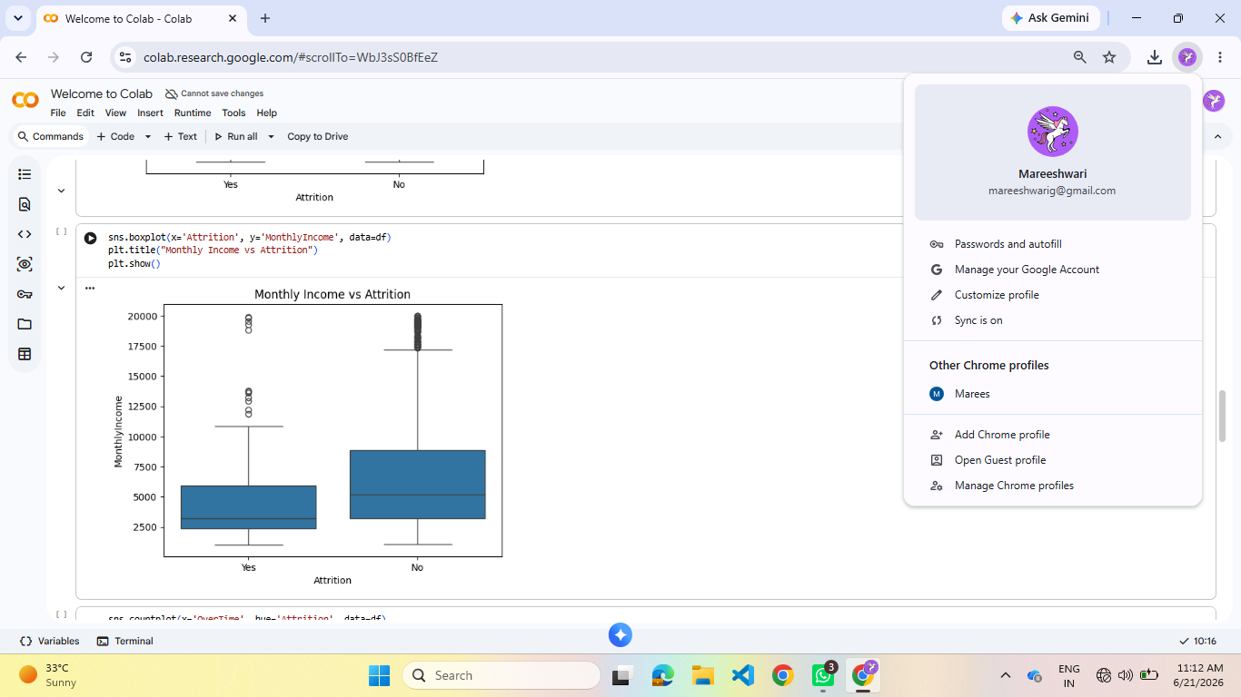

- Overtime vs Attrition Graph
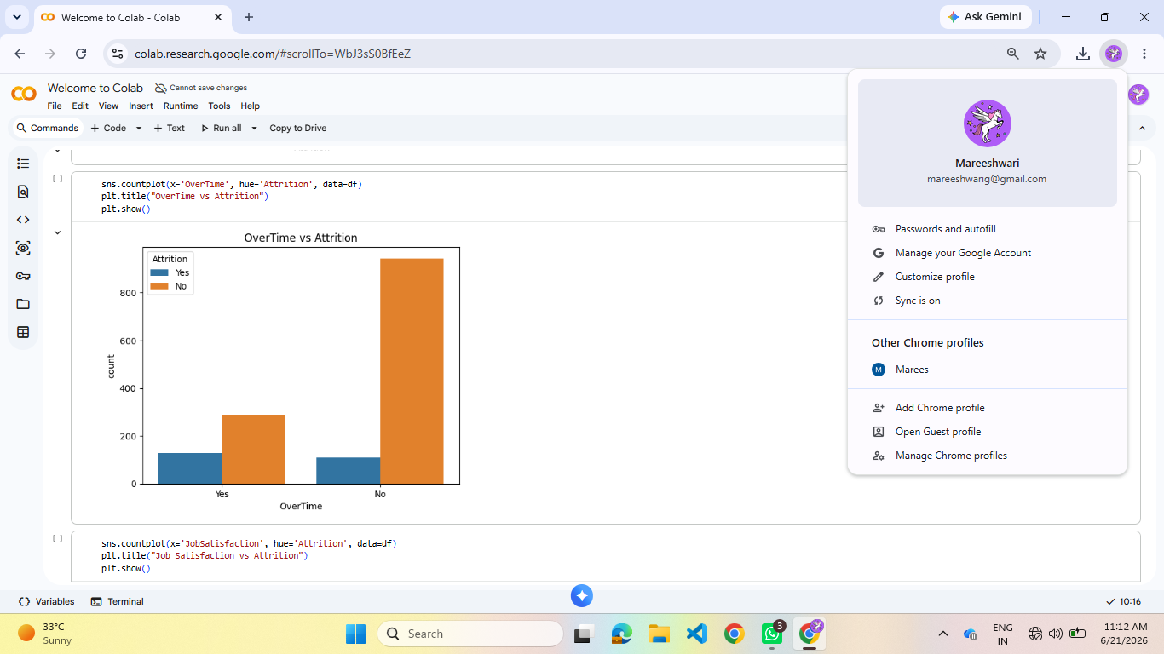

- Job Satisfaction vs Attrition Graph
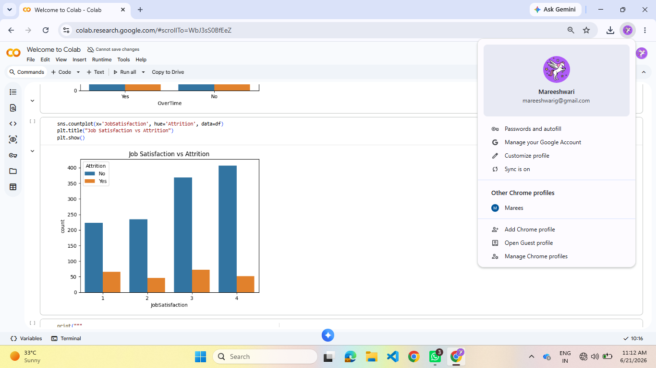

CHALLENGES FACED
- Understanding dataset columns.
- Learning visualization techniques in Python.
- Interpreting attrition-related patterns.
- Working with Google Colab environment.
- Used Python documentation and practice examples.
- Applied EDA techniques to understand the data.

LEARNING OUTCOMES

Technical Learning

Python Programming

Data Analysis

Data Visualization

Google Colab Usage

Practical Experience

Working with real-world HR datasets.

Identifying business insights through data.

Creating analytical reports and visualizations.

CONCLUSION

The HR Employee Attrition Analysis project successfully identified important factors affecting employee turnover. The analysis showed that overtime work, lower income, and job satisfaction significantly influence attrition. The project demonstrated how Python and data analytics can be used to derive meaningful business insights and support better decision-making for employee retention.

